Classifying Earthquake-Triggered Landslide Susceptibility: Using Machine Learning to Predict Landslide-Prone Slopes in the 2015 Gorkha Earthquake Region, Nepal
Unique Rajak (Student ID: 17626107)
STW7072CEM Machine Learning, March Intake 2026 – Project Proposal
Softwarica College of IT & E-Commerce (in collaboration with Coventry University) · Module Leader: Shrawan Thakur

I. Problem and Significance
The 25 April 2015 M7.8 Gorkha earthquake and its 12 May M7.3 aftershock caused thousands of landslides in Nepal. These landslides blocked roads and rivers. Buried entire villages. Most hazard maps in Nepal are made using data from monsoon-related landslides, which happen due to rainfall. Earthquakes cause landslides in different places especially on steep upper slopes and ridges. These areas may be considered safe on hazard maps because they don’t fail during rain. The project frames the challenge as a binary classification problem: given the terrain, geology and ground shaking at a location did it fail during the earthquake? This is not an academic question. It’s a real-world issue with direct impacts on human lives, infrastructure and recovery efforts, across the Himalayan region.
II. Objectives
- Identify high-risk slopes before the earthquake: create a four-class susceptibility map (Low to Very High) so planners can avoid building new roads, schools, hydropower access routes and resettlement sites on the most failure-prone slopes.
- Explain what makes a slope fail: how ground shaking, slope steepness, elevation changes and rock type contribute to landslides helping to determine where slope stabilization and stricter building rules are most needed.
- Test whether current hazard maps are enough: compare how well a model trained on rainfall-induced landslides predicts earthquake-triggered landslides and show how much it under-predicts to support updates, to Nepal’s disaster-risk planning.
- Support rapid emergency response: demonstrate that combining the trained model with the USGS ShakeMap can quickly highlight landslide zones within hours after an earthquake helping rescue teams and road-clearing crews respond faster.
III. Datasets
Labels: ICIMOD Regional Database System, “Landslide data of 14 earthquake-affected districts of Nepal”: 4,747 mapped polygons across 13 districts (2,477 co-seismic, 1,857 pre-earthquake, dated by satellite image). An independent ICIMOD inventory of 551 landslides at Bahrabise, Sindhupalchok is kept as an external test set.
Features: SRTM 90 m DEM (elevation, slope, aspect, curvature, relief); USGS ShakeMap grids for both shocks (PGA, PGV); ICIMOD Geology of Nepal (rock formation). All data are public and already downloaded and checked. Early checks show a median slope of 34° at landslides versus 22° overall, and a median PGA of 61 %g versus 51 %g.
IV. Proposed Methodology
The workflow (Fig. 1) runs from three inputs to one explained susceptibility map, with two models trained side by side.
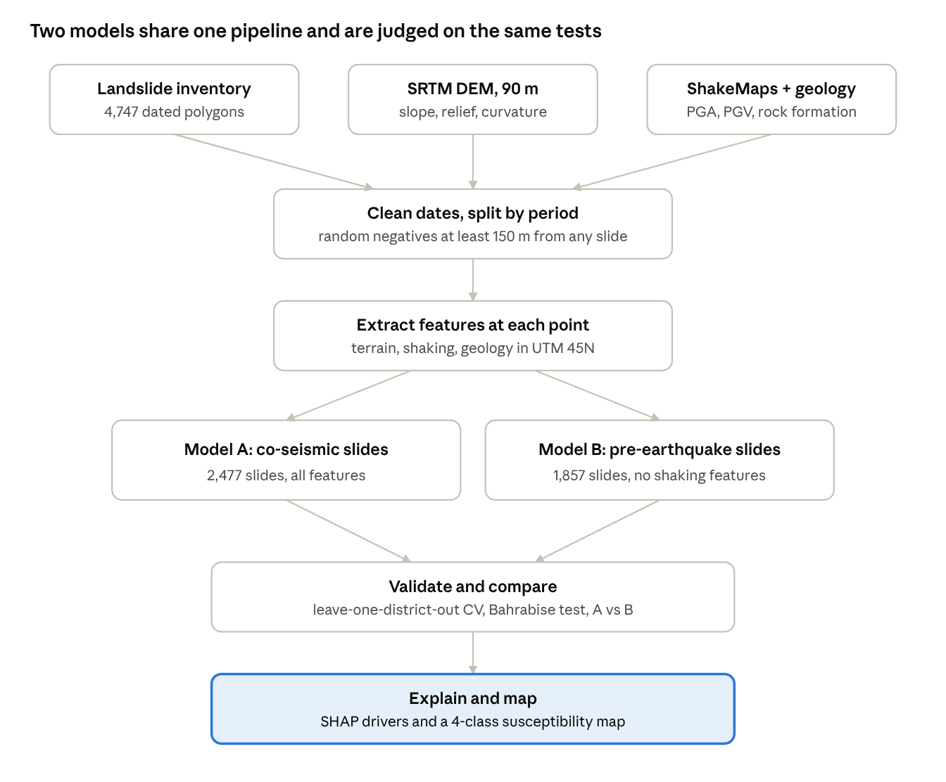
Fig. 1. Proposed project workflow.
Pre-processing: parse image dates, remove 19 records, split pre- and post-earthquake landslides change all layers to UTM 45N and collect an equal number of non-landslide points at least 150 meters away from any landslide. Features are adjusted to be consistent; PCA is used to look at terrain variables..
Classifiers: (1) Logistic Regression, an interpretable linear baseline; (2) Support Vector Machine with an RBF kernel; (3) Random Forest, a decision-tree ensemble. Hyperparameters are tuned by grid search inside the folds, and a Frequency Ratio statistical baseline is reported for comparison.
Evaluation: use leave-one-district-out cross-validation to stop leakage; measure ROC-AUC, PR-AUC, precision, recall and F1; test, on Bahrabise; and use SHAP values to explain the best model. A second model built on pre-earthquake landslides (Model B) is tested on co-seismic landslides to see how badly a rainfall-era map predicts earthquake failures.
V. Expected Outcomes, Ethics and Plan
Outputs: a Google Colab notebook with run instructions and a screencast; a four-class susceptibility map; model comparison and SHAP analysis; and an IEEE-format paper of about 6,000 words. Ethics: public, non-personal data used under CC BY 4.0 and USGS public-domain terms; the map will be labelled as a research product, not an official hazard zonation. Plan: literature review 28–29 Sep; data preparation 30 Sep–2 Oct; modelling and validation 3–7 Oct; mapping and SHAP 7–8 Oct; paper and code submission by 11 Oct 2026.
References
[1] ICIMOD, “Landslide data of 14 earthquake affected districts of Nepal,” Regional Database System, 2016. [Online]. Available: rds.icimod.org
[2] USGS, “ShakeMap, events us20002926 and us20002ejl,” Earthquake Hazards Program, 2015.
[3] J. S. Kargel et al., “Geomorphic and geologic controls of geohazards induced by Nepal’s 2015 Gorkha earthquake,” Science, vol. 351, no. 6269, 2016.
[4] L. Breiman, “Random forests,” Machine Learning, vol. 45, pp. 5–32, 2001.
[5] S. M. Lundberg and S.-I. Lee, “A unified approach to interpreting model predictions,” in Proc. NeurIPS, 2017.

